### RG1601 Character LCD Display Green

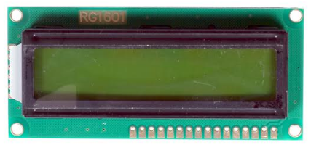 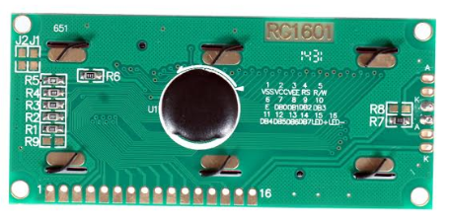

16x1 LCD with Green Backlight display based on the S6A0069 or Equivalent display controller which makes it is easy to interface this lcd most microcontrollers. It works of 5V and has Blue Backlight which can be switched on and off as desired. The contrast of the screen can also be controlled by varying the voltage at the contrast control pin.

**FEATURES:**

* Model No: RG1601
* Display Format : 16×1 Characters
* Operating Voltage: 5.0V Or 3.0V
* Display Mode : (STN,Positive,Y/G) OR(STN,NEGATIVE,BLUE) OR FSTN positive
* Polarizer Mode : Transmissive
* Driving Method : 1/16Duty, 1/5Bias
* Viewing Direction : 6 O’clock
* Backlight : Green
* Controller : S6A0069 or Equivalent.
* Operating Temperature: -10o C ~ 60o C
* Storage Temperature: -20o C ~ 70o C
* Interface : 8-Bit Parallel Interface

**SPECIFICATION:**

**ELECTRICAL CHARACTERISTICS:**

|  |  |  |  |  |  |  |
| --- | --- | --- | --- | --- | --- | --- |
| **Parameter** | **Symbol** | **Test Condition** | **Min** | **Typ** | **Max** | **Unit** |
| Supply Voltage (Logic) | VDD |  | 4.5 | 5.0 | 5.5 | V |
| Supply Voltage (LCD Drive) | VDD-VO | Ta = 25℃ | - | 4.5 | - | V |
| Input High Voltage | VIH | - | 2.2 | - | VDD | V |
| Input Low Voltage | VIL |  | -0.3 | - | 0.8 | V |
| Output High Voltage | VOH | IOH=-0.2mA | 2.4 | - | VDD | V |
| Output Low Voltage | VOL | IOL=1.2mA | 0 | - | 0.4 | V |

**MECHANICAL SPECIFICATIONS:**

|  |  |
| --- | --- |
| **Parameters** | **Description** |
| Module Size (LxWxH)mm | 80 x 36 x 13 |
| Viewing Area (LxW)mm | 64.2 x 15.7 |
| Active Area(WxH)mm | 59.45x5.95 |
| Character Size(LxW)mm | 3.2 x 5.95 |
| Dot Pitch (WxH)mm | 0.63 x 0.83 |
| Dot Size (WxH)mm | 0.55 x 0.75 |

**BLOCK DIAGRAM & POWER SUPPLY:**

|  |
| --- |
|  |

**INTERFACE PIN FUNCTION:**

|  |  |  |
| --- | --- | --- |
| **Pin No** | **Symbol** | **Description** |
| 1 | VSS | Ground for logic |
| 2 | VDD | Power supply for logic |
| 3 | VO | Power supply for LCD drive |
| 4 | RS | Register selection (H: Display data L: Instruction code) |
| 5 | R/W | Read/Write selection (H: Read operation L: Instruction code) |
| 6 | E | Enable Signal |
| 7-14 | DB0-DB7 | Data Bus lines |
| 15 | LEDA | Power supply for backlight (+) |
| 16 | LEDK | Power supply for backlight (-) |

**OUTLINE DIMENSSION:**

|  |
| --- |
|  |

**PACKAGE INCLUDES:**

1 x 16x1 LCD Display Green LED Backlight